Occupation Overview
Emsi Q3 2018 Data Set
September 2018
California
Parameters
Occupations
Code | Description
21-1021 | Child, Family, and School Social Workers
21-1029 | Social Workers, All Other
21-1093 | Social and Human Service Assistants

Regions
Code | Description
6019 | Fresno County, CA
6031 | Kings County, CA
6039 | Madera County, CA
6047 | Merced County, CA
6107 | Tulare County, CA

Timeframe
2018 - 2028
Datarun
2018.3 – QCEW Employees, Non-QCEW Employees, and Self-Employed
3 Community and Social Service Occupations in 5 California Counties
Occupation Summary for 3 Community and Social Service Occupations
5,958 |  | 17.7% |  | $19.73/hr
Jobs (2018) |  | % Change (2018-2028) |  | Median Hourly Earnings
45% above National average |  | Nation: 15.0% |  | Nation: $18.72/hr
Growth
5,958 | 7,014 |  | 1,056 |  | 17.7%
2018 Jobs | 2028 Jobs |  | Change (2018-2028) |  | % Change (2018-2028)
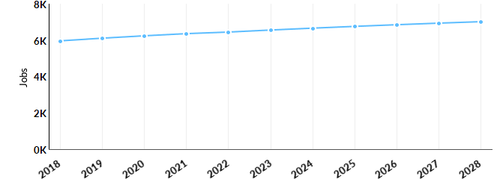
Occupation | 2018 Jobs | 2028 Jobs | Change | % Change
Child, Family, and School Social Workers (21-1021) | 2,050 | 2,426 | 376 | 18%
Social Workers, All Other (21-1029) | 1,183 | 1,224 | 41 | 3%
Social and Human Service Assistants (21-1093) | 2,725 | 3,364 | 639 | 23%

Percentile Earnings
$15.24/hr | $19.73/hr | $25.73/hr
25th Percentile Earnings | Median Earnings | 75th Percentile Earnings
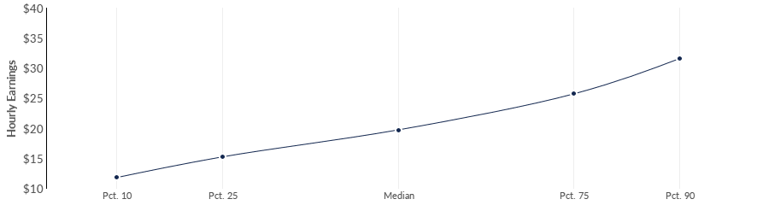
Occupation | 25th Percentile Earnings | Median Earnings | 75th Percentile Earnings
Child, Family, and School Social Workers (21-1021) | $15.81 | $20.99 | $25.97
Social Workers, All Other (21-1029) | $20.82 | $26.04 | $30.93
Social and Human Service Assistants (21-1093) | $13.37 | $17.33 | $21.38
Regional Trends
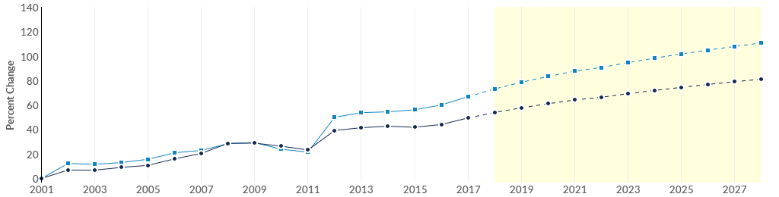
 | Region | 2018 Jobs | 2028 Jobs | Change | % Change
● | Region | 5,958 | 7,014 | 1,056 | 17.7%
● | Fresno, CA | 2,883 | 3,508 | 625 | 21.7%

Regional Breakdown
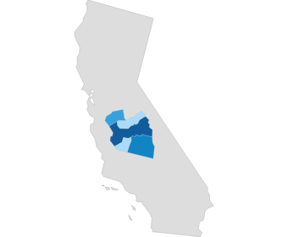
County |  | 2028 Jobs
Fresno County, CA |  | 3,508
Tulare County, CA |  | 1,415
Merced County, CA |  | 1,022
Kings County, CA |  | 637
Madera County, CA |  | 432
Job Postings Summary
822 | 3 : 1 |  | 24 days
Unique Postings | Posting Intensity |  | Median Posting Duration
2,252 Total Postings | Regional Average: 4 : 1 |  | Regional Average: 29 days
There were 2,252 total job postings for your selection from January 2018 to August 2018, of which 822 were unique. These numbers give us a Posting Intensity of 3-to-1, meaning that for every 3 postings there is 1 unique job posting.This is close to the Posting Intensity for all other occupations and companies in the region (4-to-1), indicating that they are putting average effort toward hiring for this position.
Job Postings vs. Hires
212 | 256
Avg. Monthly Postings (Jan 2018 - Aug 2018) | Avg. Monthly Hires (Jan 2018 - Aug 2018)
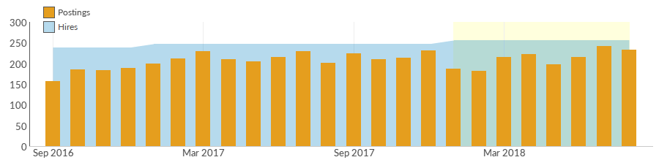
Occupation | Avg Monthly Postings (Jan 2018 - Aug 2018) | Avg Monthly Hires (Jan 2018 - Aug 2018)
Social and Human Service Assistants | 175 | 133
Child, Family, and School Social Workers | 36 | 82
Social Workers, All Other | 2 | 42
Occupation Gender Breakdown
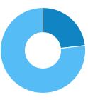
 | Gender | 2017 Jobs | 2017 Percent
● | Males | 1,343 | 23.2%
● | Females | 4,442 | 76.8%

Occupation Age Breakdown
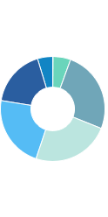
 | Age | 2017 Jobs | 2017 Percent
● | 14-18 | 7 | 0.1%
● | 19-24 | 315 | 5.4%
● | 25-34 | 1,475 | 25.5%
● | 35-44 | 1,394 | 24.1%
● | 45-54 | 1,296 | 22.4%
● | 55-64 | 1,027 | 17.7%
● | 65+ | 272 | 4.7%
Occupation Race/Ethnicity Breakdown
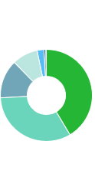
 | Race/Ethnicity |  |  |  | 2017 Jobs |  |  |  | 2017 Percent
● | Hispanic or Latino |  |  |  | 2,395 |  |  |  | 41.4%
● | White |  |  |  | 1,894 |  |  |  | 32.7%
● | Black or African American |  |  |  | 786 |  |  |  | 13.6%
● | Asian |  |  |  | 521 |  |  |  | 9.0%
● | Two or More Races |  |  |  | 140 |  |  |  | 2.4%
● | American Indian or Alaska Native |  |  |  | 36 |  |  |  | 0.6%
● | Native Hawaiian or Other Pacific Islander |  |  |  | 13 |  |  |  | 0.2%
Occupational Programs
4 |  |  | 498 |  |  | 808
Programs (2017) |  |  | Completions (2017) |  |  | Openings (2017)
CIP Code |  | Program |  |  |  |  | Completions (2017)
44.0701 |  | Social Work |  |  |  |  | 232
19.0706 |  | Child Development |  |  |  |  | 139
44.0000 |  | Human Services, General |  |  |  |  | 126
30.0501 |  | Peace Studies and Conflict Resolution |  |  |  |  | 1
Industries Employing 3 Community and Social Service Occupations
Industry |  |  |  | Occupation Group Jobs in Industry (2017) |  |  |  | % of Occupation Group in Industry (2017) |  | % of Total Jobs in Industry (2017)
Local Government, Excluding Education and Hospitals |  |  |  | 1,138 |  |  |  | 19.7% |  | 3.1%
Services for the Elderly and Persons with Disabilities |  |  |  | 973 |  |  |  | 16.8% |  | 3.5%
State Government, Excluding Education and Hospitals |  |  |  | 816 |  |  |  | 14.1% |  | 5.5%
Elementary and Secondary Schools (Local Government) |  |  |  | 355 |  |  |  | 6.1% |  | 0.6%
Child and Youth Services |  |  |  | 321 |  |  |  | 5.5% |  | 22.0%

Appendix A - Data Sources and Calculations
Location Quotient
Location quotient (LQ) is a way of quantifying how concentrated a particular industry, cluster, occupation, or demographic group is in a region as compared to the nation. It can reveal what makes a particular region unique in comparison to the national average.
Occupation Data
Emsi occupation employment data are based on final Emsi industry data and final Emsi staffing patterns. Wage estimates are based on Occupational Employment Statistics (QCEW and Non-QCEW Employees classes of worker) and the American Community Survey (Self-Employed and Extended Proprietors). Occupational wage estimates also affected by county-level Emsi earnings by industry.
Emsi Job Postings
Job postings are collected from various sources and processed/enriched to provide information such as standardized company name, occupation, skills, and geography.
Institution Data
The institution data in this report is taken directly from the national IPEDS database published by the U.S. Department of Education's National Center for Education Statistics.
State Data Sources
This report uses state data from the following agencies: California Labor Market Information Department

